Order Of Service

Singing: Psalm 67—CW page 91

Reading: Psalm 37:1-11

Opening Hymn: TLH 246

Reading: Revelation 19

Request Hymn: CW Supplement 735

Reading: John 8:39-47

Sermon Hymn: TLH 245

Sermon Text: Song Of Solomon 6:5-7

The Bridegroom Overcome

Prayer

The Apostles’ Creed, TLH page 12

Holy Communion

The Lord's Prayer

The Blessing

Closing Hymn: TLH 45

* * * * * * * * * * *

Bible Study: Lambs: Prairie Violet
Sheep: Proverbs 14:16—20

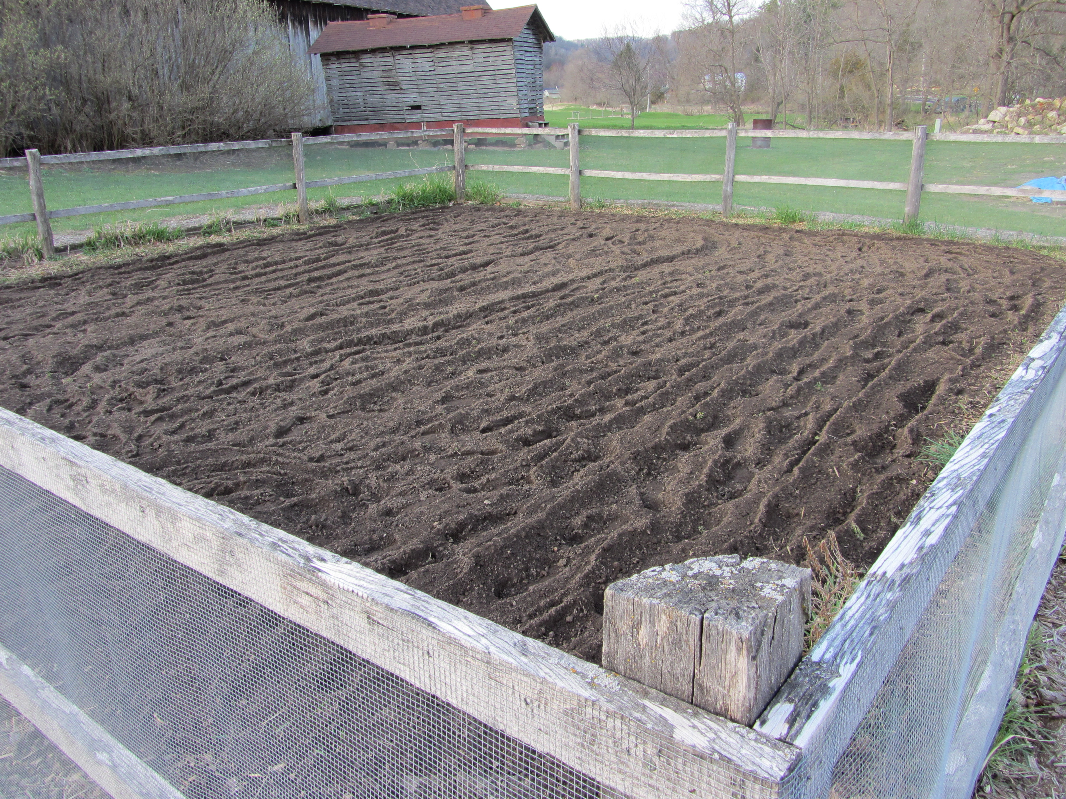

Preparing the ground so the weeds can grow.

Water
Of
Life

30 April 2017

W A T E R O F L I F E

Independent Christian Church—Conservative Lutheran Doctrine

Worship Service: 9:30 a.m. Bible Study: 10:45 a.m.

Larry Cooper, Pastor E-Mail address:
111 N. Ridge Road lcooper@wateroflife.cc
Coon Valley, WI 54623 Web Site:
Phone: (608) 452-2105 www.wateroflife.cc

* * * * * * * * * * * * * * * * * * * * * * * * * * *

Sermon Text: Song Of Solomon 6:5-7

The Bridegroom Overcome

* * * * * * * * * * * * * * * * * * * * * * * * * * *

Song of Solomon 6:5 Turn away thine eyes from me, for they have overcome me: thy hair is as a flock of goats that appear from Gilead.
:6 Thy teeth are as a flock of sheep which go up from the washing, whereof every one beareth twins, and there is not one barren among them.
:7 As a piece of a pomegranate are thy temples within thy locks.

Related Passage: Ephesians 5:22-33

22 Wives, submit yourselves unto your own husbands, as unto the Lord.
23 For the husband is the head of the wife, even as Christ is the head of the church: and he is the saviour of the body.
24 Therefore as the church is subject unto Christ, so let the wives be to their own husbands in every thing.
25 Husbands, love your wives, even as Christ also loved the church, and gave himself for her;
26 That he might sanctify and cleanse her with the washing of water by the word,
27 That he might present her to himself a glorious church, not having spot, or wrinkle, or any such thing; but that she should be holy and without blemish.
28 So ought men to love their wives as their own bodies. He that loveth his wife loveth himself.
29 For no man ever yet hated his own flesh; but nourisheth and cherisheth it, even as the Lord the church:
30 For we are members of his body, of his flesh, and of his bones.
31 For this cause shall a man leave his father and mother, and shall be joined unto his wife, and they two shall be one flesh.
32 This is a great mystery: but I speak concerning Christ and the church.
33 Nevertheless let every one of you in particular so love his wife even as himself; and the wife see that she reverence her husband.

